Full Stack Development With MERN
...............................................................
INTRODUCTION
----------------------------
Project Title: shopEZ:One-Stop Shop For Online Purchases

Team Members: Humaira Beg - 248A1F0063
Lavanya Challapalli - 248A1F0064
Pavani Chegondi - 248A1F0066
Sampurna Dasari - 248A1F0069

Project Overview
------------------------
Purpose:ShopEZ is your one-stop destination for effortless online shopping. With a user-friendly interface and a comprehensive product catalog, finding the perfect items has never been easier. Seamlessly navigate through detailed product descriptions, customer reviews, and available discounts to make informed decisions. Enjoy a secure checkout process and receive instant order confirmation. For sellers, our robust dashboard provides efficient order management and insightful analytics to drive business growth. Experience the future of online shopping with ShopEZ today.

Features:Seamless Checkout Process

Effortless Product Discovery

Personalized Shopping Experience

Efficient Order Management for Sellers

Insightful Analytics for Business Growth

Scenario: Sarah's Birthday Gift

Sarah, a busy professional, is scrambling to find the perfect birthday gift for her best friend, Emily. She knows Emily loves fashion accessories, but with her hectic schedule, she hasn't had time to browse through multiple websites to find the ideal present. Feeling overwhelmed, Sarah turns to ShopEZ to simplify her search.

1. Effortless Product Discovery: Sarah opens ShopEZ and navigates to the fashion accessories category. She's greeted with a diverse range of options, from chic handbags to elegant jewelry. Using the filtering options, Sarah selects "bracelets" and refines her search based on Emily's preferred style and budget.

2. Personalized Recommendations: As Sarah scrolls through the curated selection of bracelets, she notices a section labeled "Recommended for You." Intrigued, she clicks on it and discovers a stunning gold bangle that perfectly matches Emily's taste. Impressed by the personalized recommendation, Sarah adds it to her cart.

3.Seamless Checkout Process: With the bracelet in her cart, Sarah proceeds to checkout. She enters Emily's address as the shipping destination and selects her preferred payment method. Thanks to ShopEZ's secure and efficient checkout process, Sarah completes the transaction in just a few clicks.

4. Order Confirmation: Moments after placing her order, Sarah receives a confirmation email from ShopEZ. Relieved to have found the perfect gift for Emily, she eagerly awaits its arrival.

5. Efficient Order Management for Sellers: Meanwhile, on the other end, the seller of the gold bangle receives a notification of Sarah's purchase through ShopEZ's seller dashboard. They quickly process the order and prepare it for shipment, confident in ShopEZ's streamlined order management system.

6. Celebrating with Confidence: On Emily's birthday, Sarah presents her with the beautifully packaged bracelet, knowing it was chosen with care and thoughtfulness. Emily's eyes light up with joy as she adorns the bracelet, grateful for Sarah's thoughtful gesture.

In this scenario, ShopEZ proves to be the perfect solution for Sarah's busy lifestyle, offering a seamless and personalized shopping experience. From effortless product discovery to secure checkout and efficient order management, ShopEZ simplifies the entire process, allowing Sarah to celebrate Emily's birthday with confidence and ease.

Architecture

Frontend:The frontend is represented by the "Frontend" section, including user interface components such as User Authentication, Cart, Products, Profile, Admin dashboard, etc.,

Components:Break down the UI into reusable components(e.g.,product list,cart,login form).

State Management:Use a state management library like Redux or React Context API to manage global state(e.g.,user authentication,cart contents)

Routing:It use React Router for client-side routing(e.g.,navigating between product pages,cart,login).

API Interactions:Use Axios or Fetch API to make requests to the backend for data(e.g.,fetching products,posting orders).

Backend:The backend is represented by the "Backend" section, consisting of API endpoints for Users, Orders, Products, etc.,It also includes Admin Authentication and an Admin Dashboard.

API Endpoints:API Endpoints: Define RESTful API endpoints for frontend-backend interactions (e.g., /api/products, /api/orders, /api/auth/login).

- Authentication: Implement authentication using strategies like JWT (JSON Web Tokens) for securing endpoints.

- Middleware: Use Express.js middleware for handling requests, authentication checks, and error handling.

- Error Handling: Implement centralized error handling for API responses.

Database Schema and Interactions(MongoDB):The Database section represents the database that stores collections for Users, cart, Orders and Product.

Collections:
- Products: Store product details (e.g., name, price, description, stock).
- Users: Store user details (e.g., email, password hash, role).
- Orders: Store order details (e.g., user ID, products, total, status).
- Interactions:
- Use Mongoose or MongoDB driver for Node.js to interact with MongoDB.
- Perform CRUD operations (create, read, update, delete) for products, users, orders.

Setup Instructions
the setup instructions for the ShopEZ online products application, including prerequisites and a step-by-step installation guide.

## Prerequisites
To set up and run the ShopEZ application, you'll need the following software dependencies installed on your machine:

- Node.js: Version 16 or later (for running the backend and potentially build scripts for the frontend).
- MongoDB: For storing application data (products, users, orders).
- npm or yarn: For managing dependencies and running scripts.

## Installation
Follow these steps to clone, install dependencies, and set up the environment variables for the ShopEZ application:

### Step 1: Clone the Repository
git clone https://github.com/your-repo/shopEZ.git
cd shopEZ

(Replace https://github.com/your-repo/shopEZ.git with the actual repository URL if different.)

### Step 2: Install Dependencies
Assuming you have a typical Node.js project structure with a backend and possibly a frontend folder:
# Install backend dependencies
cd backend
npm install

# If there's a frontend folder using React, install its dependencies too
cd ../frontend
npm install

### Step 3: Set Up Environment Variables
You'll need to set up environment variables for the application. Typically, this involves creating a .env file in the backend directory with variables like:
# .env in backend folder
MONGO_URI=mongodb://localhost:27017/shopEZ
JWT_SECRET=your-secret-key-for-jwt
PORT=3001

- MONGO_URI: Connection string for your MongoDB instance.
- JWT_SECRET: Secret key for signing JWT tokens for authentication.
- PORT: Port on which the backend server will run.

### Step 4: Run the Application
# Start the backend server
cd backend
npm start

# In a separate terminal, if applicable, start the frontend development server
cd frontend
npm start

## Next Steps
- Populate the database: You might need to add initial data (like products) to MongoDB for testing.
- Test the application: Verify that both frontend and backend are working as expected by navigating to the application in a browser (usually http://localhost:3000 for React frontend if using default settings).

## Folder Structure

### Client (React Frontend)

The client folder contains the structure for the React frontend. Here's what's in it:
- public: Typically holds public assets and the main entry point for the app.
- Src: Contains the source code for the React application.
- .gitignore: Specifies files to ignore in version control.
- Package-lock.json: Automatically generated for npm operations.
- Package.json: Holds metadata and dependencies for the project.
- README.md: Documentation for the project.

### Server (Node.js Backend)

The server folder is organized for the Node.js backend. Here's the breakdown:
- controllers: Handles business logic for routes.
- middleware: Contains custom middleware functions for the app.
- models: Defines database models (likely for MongoDB given the context of ShopEZ).
- routes: Defines API routes for the backend.
- .env: Stores environment variables for the project.
- index.js: Main entry point for the Node.js server.
- Package-lock.json: Automatically generated for npm operations.
- Package.json: Holds metadata and dependencies for the project.

## Running the Application
To run the ShopEZ application locally, you'll need to start both the frontend and backend servers. Here are the commands:

### Start the Frontend Server
Navigate to the client directory and run:
cd client
npm start

This will start the React development server, typically making the app available at http://localhost:3000.

### Start the Backend Server
In a separate terminal, navigate to the server directory and run:
cd server
npm start

This will start the Node.js backend server, likely running on a port specified in the .env file (like http://localhost:3001).

## Next Steps
- Access the application: Open a browser and go to http://localhost:3000 to view the ShopEZ frontend.
- Test functionality: Try logging in, browsing products, or other features to ensure both frontend and backend are communicating correctly.

## API Endpoints

Authentication

- POST /api/auth/login

- Parameters: email, password
- Example Response: { "token": "jwt-token", "user": { "id": "user-id", "email": "user@example.com" } }

- POST /api/auth/register

- Parameters: email, password
- Example Response: { "message": "User registered successfully", "user": { "id": "user-id", "email": "user@example.com" } }

### Products

- GET /api/products

- Parameters: None
- Example Response: [ { "id": "product-id", "name": "Product Name", "price": 10.99 }, ... ]
- GET /api/products/:id
- Parameters: id (product ID)
- Example Response: { "id": "product-id", "name": "Product Name", "price": 10.99 }

### Orders

- POST /api/orders

- Parameters: products (array of product IDs and quantities), userId
- Example Response: { "message": "Order placed successfully", "order": { "id": "order-id", "total": 21.98 } }

- GET /api/orders

- Parameters: None
- Example Response: [ { "id": "order-id", "userId": "user-id", "total": 21.98 }, ... ]

### User Profile

- GET /api/users/:id
- Parameters: id (user ID)
- Example Response: { "id": "user-id", "email": "user@example.com" }

## Notes

- Authentication: Some endpoints might require a valid JWT token in the Authorization header.
- Error Handling: Endpoints typically return error responses with a message indicating the issue (e.g., { "message": "Product not found" }).

## Authentication and Authorization

In the ShopEZ project, authentication and authorization are likely handled using JSON Web Tokens (JWT). This is a common approach for securing RESTful APIs.

### Authentication

- Login: When a user logs in with valid credentials (email and password), the backend verifies the credentials.

- Token Generation: Upon successful verification, the backend generates a JWT token containing user details (like userId, email) and sends it back to the client.

- Client-Side Storage: The client (React frontend) typically stores this token in local storage or cookies.

### Authorization

- Token Validation: For protected routes (like placing an order or accessing user-specific data), the client includes the JWT token in the Authorization header of requests.

- Backend Verification: The backend verifies the token on each request to protected endpoints. If valid, it grants access; otherwise, it returns an error (like 401 Unauthorized).

### Methods Used

- JWT Tokens: Used for stateless authentication, allowing the backend to verify requests without needing server-side sessions.

- No Sessions: Since JWT is stateless, there's no need for traditional session management on the server.

## Security Considerations

- Token Expiration: JWT tokens can have an expiration time for security.

- Secure Storage: On the client, tokens should be stored securely (like using HTTP-only cookies for better security against XSS).

User Interface:

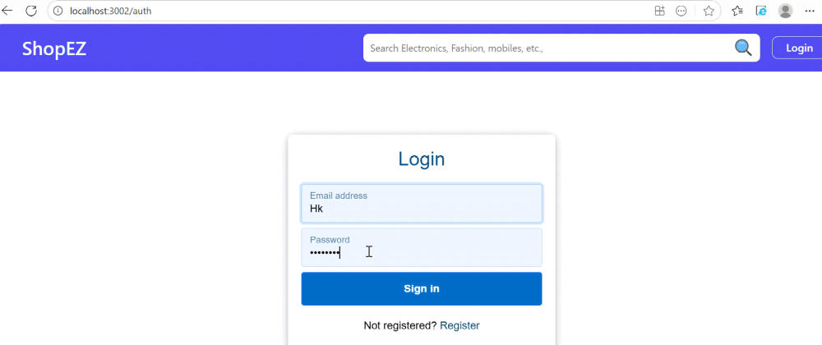

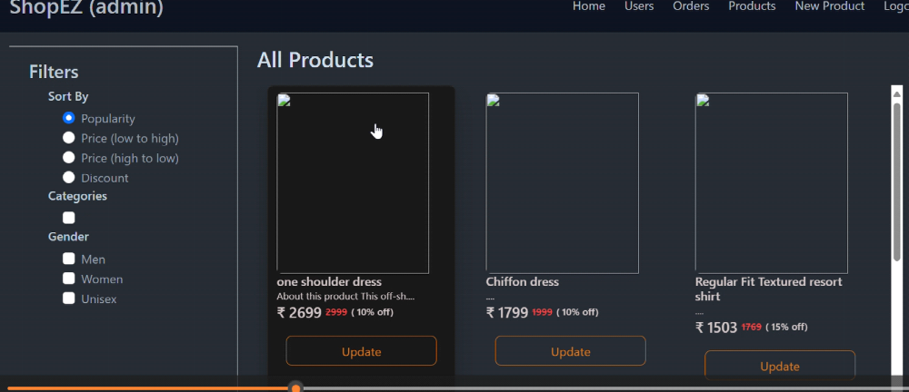

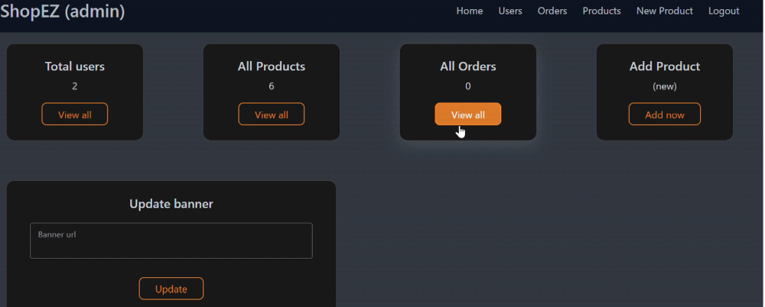

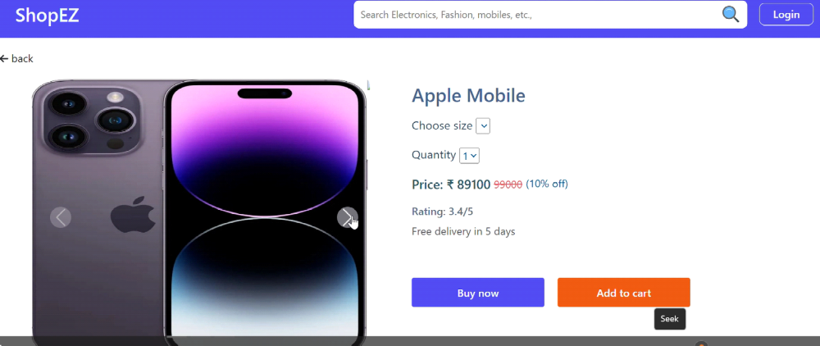

## Testing Strategy and Tools

For the ShopEZ application, a typical testing strategy involves a combination of unit tests, integration tests, and potentially end-to-end (E2E) tests to ensure the application works as expected.

### Testing Tools

- Backend (Node.js):

- Jest: A popular testing framework for unit and integration tests.
- Supertest: For testing API endpoints.

- Frontend (React):

- Jest: For unit testing components and logic.
- React Testing Library: For testing React components' behavior.

### Testing Strategy

- Unit Tests: Test individual functions, models, or components in isolation.
- Integration Tests: Test how parts of the application work together (like API routes interacting with the database).
- E2E Tests: Optionally, test the entire application flow (like user login, adding products to cart, checkout) using tools like Cypress.

## Example Testing Scenarios

- Test if a user can successfully log in via the /api/auth/login endpoint.
- Test if a product is correctly added to the cart in the React frontend.
- Test API endpoints for products to ensure they return data as expected.

Screenshots or Demo

## Known Issues

For the ShopEZ application, here are some potential known issues that users or developers might need to be aware of. Since ShopEZ is a hypothetical application for this conversation, I'll outline common issues that could apply to an e-commerce app like ShopEZ:

- Cart Sync Issue: Potential issue with cart data syncing between logged-in and guest states.
- Payment Gateway Integration Bugs: Possible issues with payment processing in live mode.
- Product Image Upload Bugs: Issues might occur when uploading product images in certain formats or sizes.

## Workarounds or Fixes

- For cart sync issues, ensure users log in before adding items to the cart.
- For payment gateway issues, double-check API keys and configurations.
- For image upload bugs, validate image formats and sizes on upload.

## Future Enhancements

For the ShopEZ application, here are some potential future features or improvements that could enhance the project:

- Wishlist Feature: Allow users to save products for later.
- Product Reviews and Ratings: Enable users to leave reviews and ratings for products.
- Advanced Search Filters: Add more filters for searching products (like by brand, price range, etc.).
- Order Tracking: Allow users to track their order status.
- Multi-Language Support: Support multiple languages for a broader user base.
- Performance Optimizations: Improve page load times and overall performance.

## Potential Improvements

- UI/UX Enhancements: Improve the user interface and experience for better engagement.
- Security Enhancements: Implement additional security measures like two-factor authentication.
- Analytics Integration: Add analytics to track user behavior and improve marketing strategies.

